Project Initialization and Planning Phase

Date | 29 September 2026
Team ID | SWTID-2026-3922
Project Name | AI FAQ Assistant API
Maximum Marks | 3 Marks

Define Problem Statements (Customer Problem Statement Template):

I am a customer seeking quick support. I'm trying to get answers to my questions quickly, but I often have to wait for customer support because FAQs may be difficult to find and support teams may take time to respond, which makes me feel frustrated and dissatisfied.

Example:

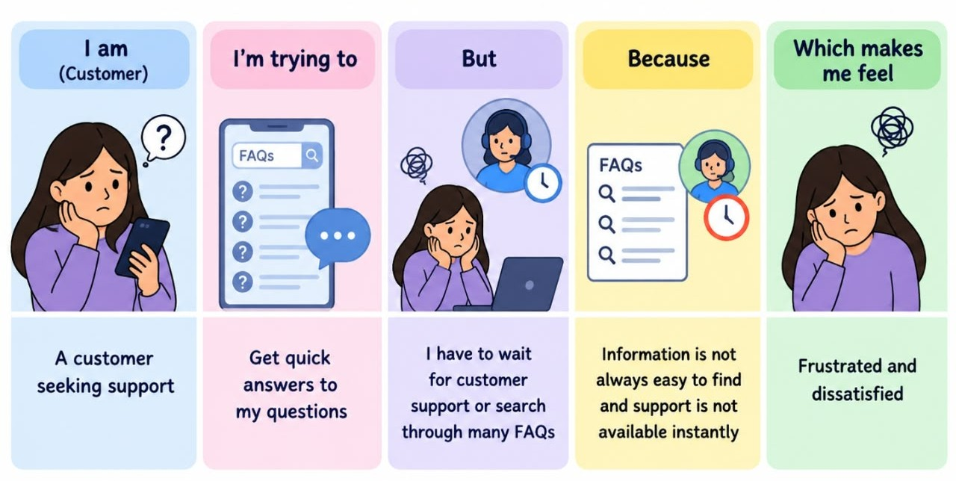

Problem Statement (PS) | I am (Customer) | I’m trying to | But | Because | Which makes me feel
PS-1 | A customer seeking support | Get instant answers to my questions | I cannot find the right information quickly income. | FAQs are difficult to search and customer support may take time to respond  Which makes me feel: Frustrated | Frustrated and dissatisfied.

